 | Patient-Tracker-Analysis  Technical Design Document  1.0
 | Prepared By / Last Updated By | Reviewed By | Approved By
Name | Priyasha Duvedi | Pratik Pritam | Poonkuzhali Anand
Role | Team Member | Team Member | Scrum Master
Signature
Date

Table of Contents

1.0 Introduction 3
1.1 Purpose of this document 3
1.2 Scope 3
1.3 Intended Audience 3
1.4 Definition & Acronyms 3
2.0 Conventions and Standards Followed 4
3.0 Assumptions, Dependencies and Risks 4
3.1 Assumptions: 4
3.2 Dependencies: 4
4.0 Schematic Diagram 4
5.0 Use Case Realization 5
5.1.1 User Registration 5
a. Functional Requirement 6
b. UI Validations 6
c. UI Controls 7
d. UI Methods Definition 8
e. UI Design 9
6.0 Database Design 10
6.1 Data Model 10
6.2 Tables Structure 10
7.0 Change Log 13

Introduction

Purpose of this document
The purpose of the detail design document is to define the detailed design for all the components of Patient Tracker Analysis system that are specified in the Business Requirement/Use case document. All the low-level components, interfaces and integrations are detailed out in this document.

Scope
This sub-section shall state the scope of this detailed design document
• Create and maintain Admin Information.
• Create and maintain patient’s information.
• Create and maintain doctor’s information.
• Create and maintain medicine’s information.
• Create and maintain clerk’s information.
• Create and maintain prescription’s information.
• Create and maintain bill’s information.

Intended Audience
The intended audience for this document are
- Developers, testers, other associates in the project
- Technical lead, Scrum Master
- Product Owner

Assumptions, Dependencies and Risks

Assumptions:
- Once the application is built the PATIENT TRACKER ANALYSIS the admin either be able to login directly if they are an existing user and will be able to register if a new user comes.
- There will be no concurrent users for the application.
- Any changes to the design mentioned in the BRD would be taken as a Change Request

Dependencies:
- Availability of database design characteristics & access shall be defined by the role.
- Resource availability throughout each of the sprint

Use Case Realization

Login
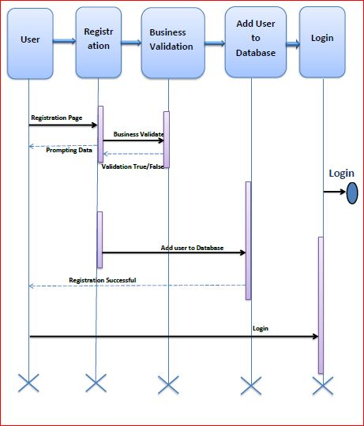

Functional Requirement
. Login Page authenticates the username and password for existing users and for new users leads them to register page. If the authentication is approved then leads them to home page which shows various tabs leading them to the different options leading to various functionalities.

UI Validations
- User Id and Password fields are mandatory.
- Invalid User Id and / or password should not allow the user to get into the system

UI Controls
# | UI Component | Type | Name | Details
1 | Admin Id | Label | label_For_Admin_Id
2 | Admin | Text field | Textfield_Admin | To enter username
3 | Password | Label | Label_for_password
4 | Password | Text field | Textfield_password | To enter password

Method Name | Parameter | Details
LogintButton_click | Object sender | Enables the admin to Home Page only after proper authentication.
Register_click | Object sender | Enables a new user to register and create a profile to access all the facilities.
Logo_click | Object sender | Enables the user to view the information about the company.

UI Methods

UI Design
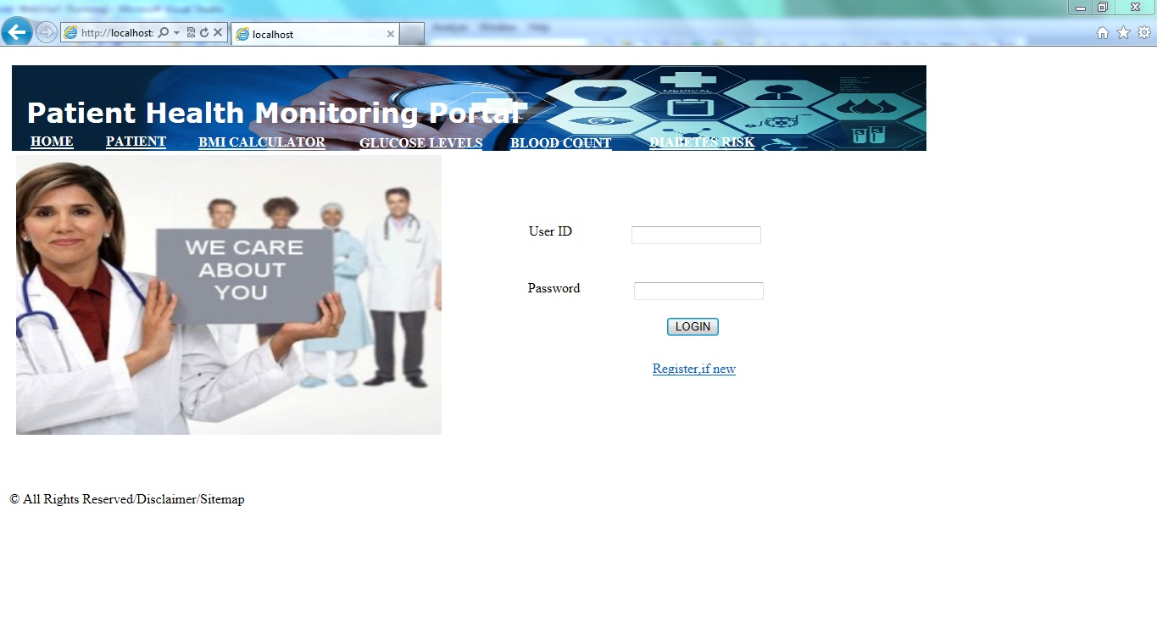

Clerk
- Functional Requirement
Clerk Page show the list of all the clerks that are present in the database, with the option of searching each clerk through the search bar and adding a clerk through the add option button.

UI Validations
- User Id and Password fields are mandatory.
- Invalid User Id and / or password should not allow the user to get into the system

- UI Controls

#UI Component | Type | Name | Details
AddButton | link | addButton | Functionality to add a clerk.
SearchBar | text | searchBar | Lists the details of the clerks according to the letters that are typed.

UI Method Definitions

Method Name | Parameter | Details
LogoutButton_click | Object sender | Enables a pop up and asks whether you want to logout or not
AddButton_click | Object sender | Enables the admin to a new clerk with its respective details which is inserted into the database
SearchBar_type | Object sender | Enables the admin to filter out to filter out the clerk details according to the letter that are typed
IdButton_click | Object sender | Enables the admin to see the full details of the Clerks
Logo_click | Object sender | Redirects to the dashboard page from anywhere

UI Design

Doctor
a. Functional Requirement
Doctor Page show the list of all the doctors that are present in the database, with the option of searching each doctor through the search bar and adding a doctor through the add option button.

UI Validations
- User Id and Password fields are mandatory.
- Invalid User Id and / or password should not allow the user to get into the system

- UI Controls

#UI Component | Type | Name | Details
AddButton | link | addButton | Functionality to add a clerk.
SearchBar | text | searchBar | Lists the details of the clerks according to the letters that are typed.

UI Method Definitions

Method Name | Parameter | Details
LogoutButton_click | Object sender | Enables a pop up and asks whether you want to logout or not
AddButton_click | Object sender | Enables the admin to a new doctor with its respective details which is inserted into the database
SearchBar_type | Object sender | Enables the admin to filter out to filter out the doctor details according to the letter that are typed
IdButton_click | Object sender | Enables the admin to see the full details of the Doctors
Logo_click | Object sender | Redirects to the dashboard page from anywhere

- UI Design

Patient
a. Functional Requirement
Patient Page show the list of all the patients that are present in the database, with the option of searching each patient through the search bar and adding a patient through the add option button.

UI Validations
- User Id and Password fields are mandatory.
- Invalid User Id and / or password should not allow the user to get into the system

- UI Controls

#UI Component | Type | Name | Details
AddButton | link | addButton | Functionality to add a clerk.
SearchBar | text | searchBar | Lists the details of the clerks according to the letters that are typed.

Method Name | Parameter | Details
LogoutButton_click | Object sender | Enables a pop up and asks whether you want to logout or not
AddButton_click | Object sender | Enables the admin to a new patient with its respective details which is inserted into the database
SearchBar_type | Object sender | Enables the admin to filter out to filter out the doctor details according to the letter that are typed
IdButton_click | Object sender | Enables the admin to see the full details of the Patients
Logo_click | Object sender | Redirects to the dashboard page from anywhere
- UI Method Definitions

- UI Design

Medicine
a. Functional Requirement
Patient Page show the list of all the medicines that are present in the database, with the option of searching each medicine through the search bar and adding a patient through the add option button.

UI Validations
- User Id and Password fields are mandatory.
- Invalid User Id and / or password should not allow the user to get into the system

- UI Controls

#UI Component | Type | Name | Details
AddButton | link | addButton | Functionality to add a clerk.
SearchBar | text | searchBar | Lists the details of the clerks according to the letters that are typed.

Method Name | Parameter | Details
LogoutButton_click | Object sender | Enables a pop up and asks whether you want to logout or not
AddButton_click | Object sender | Enables the admin to a new medicine with its respective details which is inserted into the database
SearchBar_type | Object sender | Enables the admin to filter out to filter out the medicine details according to the letter that are typed
IdButton_click | Object sender | Enables the admin to see the full details of the Medicines.
Logo_click | Object sender | Redirects to the dashboard page from anywhere

- UI Method Definitions

- UI Design

Prescription

a. Functional Requirement
Prescription Page show the list of all the prescriptions that are present in the database, with the option of searching each prescription through the search bar and adding a patient through the add option button.

UI Validations
- User Id and Password fields are mandatory.
- Invalid User Id and / or password should not allow the user to get into the system

- UI Controls
#UI Component | Type | Name | Details
AddButton | link | addButton | Functionality to add a clerk.
SearchBar | text | searchBar | Lists the details of the clerks according to the letters that are typed.

Method Name | Parameter | Details
LogoutButton_click | Object sender | Enables a pop up and asks whether you want to logout or not
AddButton_click | Object sender | Enables the admin to a new Prescription with its respective details which is inserted into the database
SearchBar_type | Object sender | Enables the admin to filter out to filter out the Prescription details according to the letter that are typed
IdButton_click | Object sender | Enables the admin to see the full details of the Prescriptions.
Logo_click | Object sender | Redirects to the dashboard page from anywhere

- UI Method Definitions

- UI Design

Bill
a. Functional Requirement
Bill Page show the list of all the bills that are present in the database, with the option of searching each bill through the search bar and adding a patient through the add option button.

UI Validations
- User Id and Password fields are mandatory.
- Invalid User Id and / or password should not allow the user to get into the system

- UI Controls
#UI Component | Type | Name | Details
AddButton | link | addButton | Functionality to add a clerk.
SearchBar | text | searchBar | Lists the details of the clerks according to the letters that are typed.

Method Name | Parameter | Details
LogoutButton_click | Object sender | Enables a pop up and asks whether you want to logout or not
AddButton_click | Object sender | Enables the admin to a new Bill with its respective details which is inserted into the database
SearchBar_type | Object sender | Enables the admin to filter out to filter out the Bill details according to the letter that are typed
IdButton_click | Object sender | Enables the admin to see the full details of the Bills.
Logo_click | Object sender | Redirects to the dashboard page from anywhere

- UI Method Definitions

- UI Design

Error
a. Functional Requirement
This is the error page which will be displayed in case of any error arises.

- UI Controls

#UI Component | Type | Name | Details
HomeButton | link | addButton | Redirects to the dashboard page from anywhere
ContactUsButton | text | searchBar | Lists the details of the clerks according to the letters that are typed.

Method Name | Parameter | Details
LogoutButton_click | Object sender | Enables a pop up and asks whether you want to logout or not
gotoHomeButton_click | Object sender | Redirects to the dashboard page from anywhere
Logo_click | Object sender | Redirects to the dashboard page from anywhere
- UI Design

Database Design

Data Model

The following is a schematic view of the database design
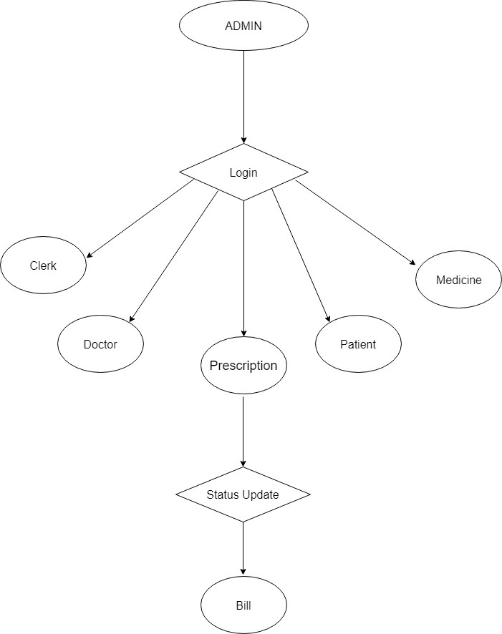

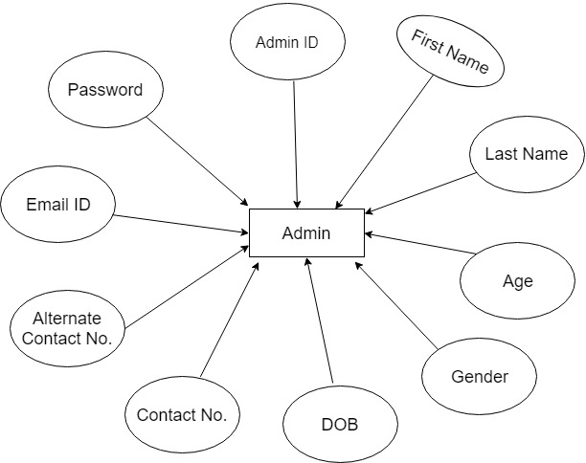

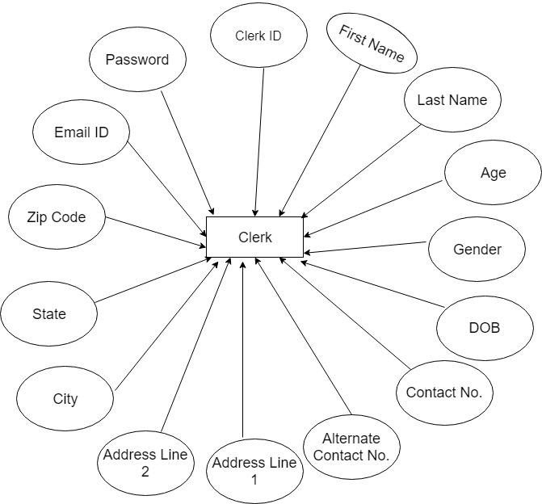

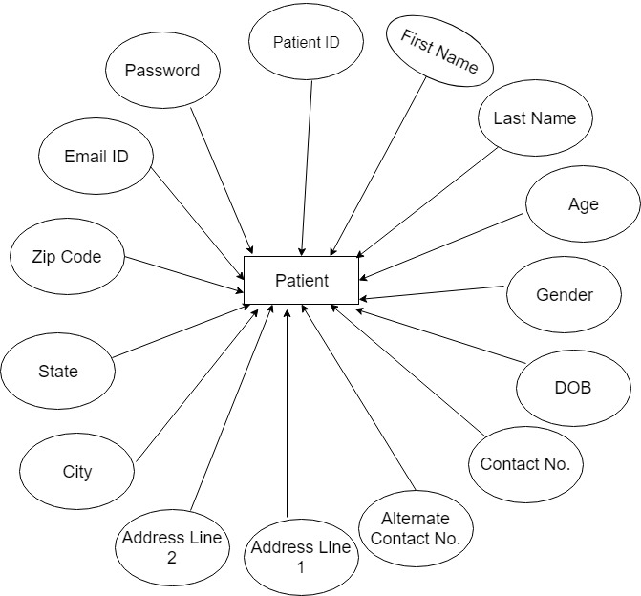

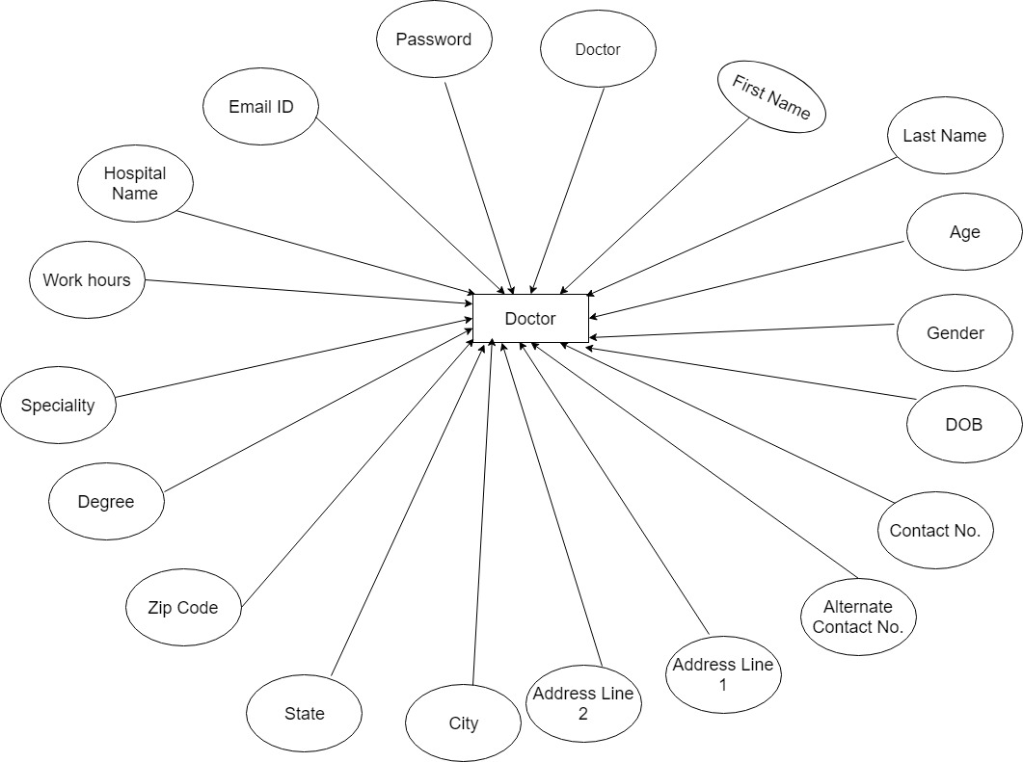

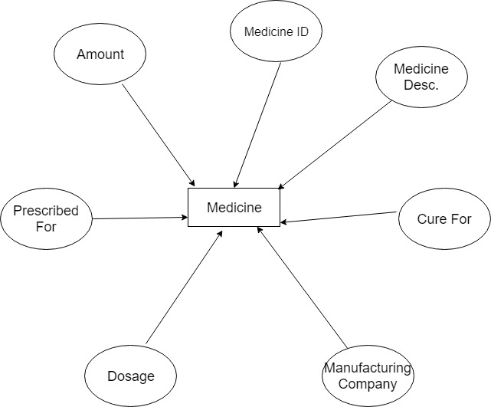

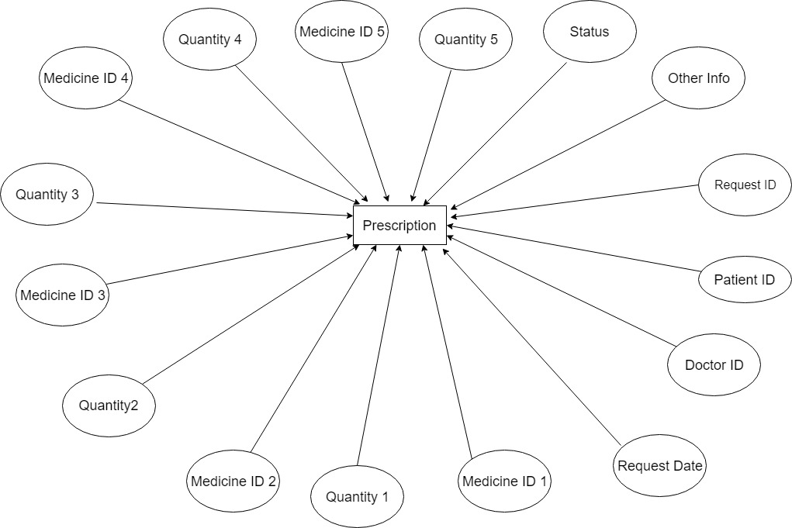

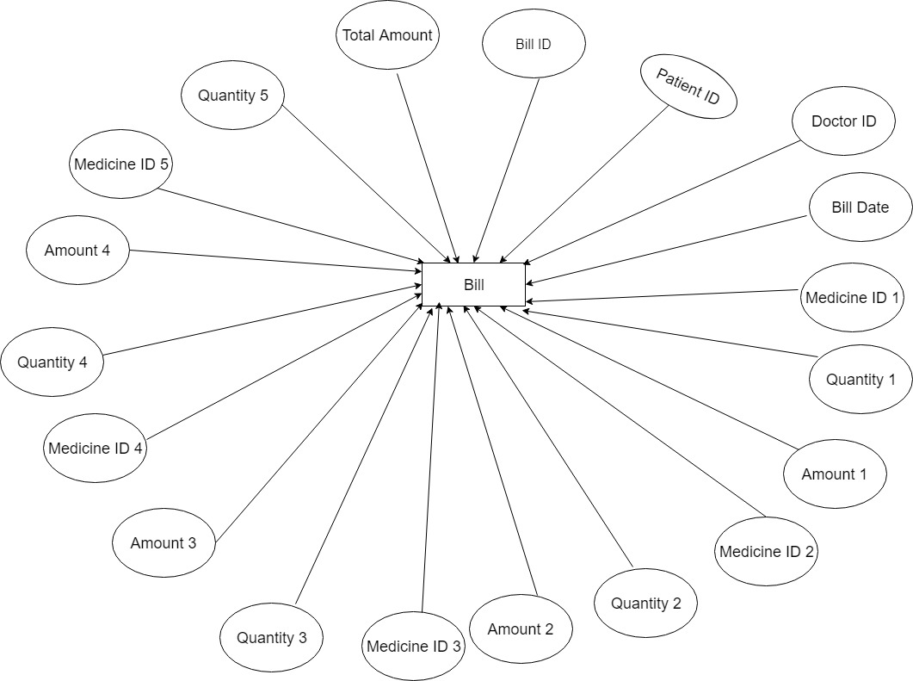

Tables Structure
Admin Registration:
Column Name | Data Type | Length | Nulls
Admin Id | varchar | 10 | N
Password | varchar | 15 | N
First Name | varchar | 50 | N
Last Name | varchar | 50 | N
Age | int | 5 | N
Gender | varchar | 10 | N
Contact Number | int | 10 | N
Email | varchar | 50 | N
Alternate Contact Number | int | 10 | Y

Clerk Registration:
Column Name | Data Type | Length | Nulls
Clerk Id | varchar | 10 | N
First Name | varchar | 50 | N
Last Name | varchar | 50 | N
Age | int | 2 | N
Gender | varchar | 10 | N
Date Of Birth | date |  | Y
Email Address | varchar | 50 | N
Contact Number | int | 10 | N
Alternate Contact Number | int | 10 | Y
Address Line 1 | varchar | 250 | N
Address Line 2 | varchar | 250 | N
City | varchar | 50 | N
State | varchar | 50 | N
Zipcode | varchar | 10 | N

Doctor Registration:
Column Name | Data Type | Length | Nulls
Doctor Id | varchar | 10 | N
First Name | varchar | 50 | N
Last Name | varchar | 50 | N
Age | int | 2 | N
Gender | varchar | 10 | N
Date Of Birth | date |  | Y
Email Address | varchar | 50 | N
Contact Number | int | 10 | N
Alternate Contact Number | int | 10 | Y
Address Line 1 | varchar | 250 | N
Address Line 2 | varchar | 250 | N
City | varchar | 50 | N
State | varchar | 50 | N
Zipcode | varchar | 10 | N
Degree | varchar | 50 | N
Speciality | varchar | 50 | N
Work Hours | int | 12 | N
Hospital Name | varchar | 100 | N

Patient Registration:
Column Name | Data Type | Length | Nulls
Patient Id | varchar | 10 | N
First Name | varchar | 50 | N
Last Name | varchar | 50 | N
Age | int | 2 | N
Gender | varchar | 10 | N
Date Of Birth | date |  | Y
Email Address | varchar | 50 | N
Contact Number | int | 10 | N
Alternate Contact Number | int | 10 | Y
Address Line 1 | varchar | 250 | N
Address Line 2 | varchar | 250 | N
City | varchar | 50 | N
State | varchar | 50 | N
Zipcode | varchar | 10 | N

Medicine Registration:
Column Name | Data Type | Length | Nulls
Medicine Id | int | 8 | N
Medicine Description | varchar | 200 | N
Cure For | varchar | 100 | N
Manufacturing Company | varchar | 50 | N
Dosage | int | 3 | N
Prescribed For | varchar | 1 | N
Amount | int | 6 | N

Prescription Registration:
Column Name | Data Type | Length | Nulls
Request Id | int | 8 | N
Patient Id | int | 10 | N
Doctor Id | int | 10 | N
Request Date | date |  | N
MedicineID1 | Int |  | N
Quantity1 | int | 3 | N
MedicineID2 | int |  | Y
Quantity2 | int | 3 | Y
MedicineID3 | int |  | Y
Quantity3 | int | 3 | Y
MedicineID4 | int |  | Y
Quantity4 | int | 3 | Y
MedicineID5 | int |  | Y
Quantity5 | int | 3 | Y
Other Info | varchar | 200 | Y
Status | varchar | 1 | N

Bill Creation:
Column Name | Data Type | Length | Nulls
BillId | int | 8 | N
Patient Id | int | 10 | N
Doctor Id | int | 10 | N
Bill Date | date |  | N
MedicineID1 | Int |  | N
Quantity1 | int | 3 | N
Amount1 | int | 6 | N
MedicineID2 | int |  | Y
Quantity2 | int | 3 | Y
Amount2 | int | 6 | Y
MedicineID3 | int |  | Y
Quantity3 | int | 3 | Y
Amount3 | int | 6 | Y
MedicineID4 | int |  | Y
Quantity4 | int | 3 | Y
Amount4 | int | 6 | Y
MedicineID5 | int |  | Y
Quantity5 | int | 3 | Y
Amount5 | int | 6 | Y
Other Info | varchar | 200 | Y
Status | varchar | 1 | N

Change Log
Please note that this table needs to be maintained even if a Configuration Management tool is used.
Version Number | Changes made
V1.0 | <First version>
V1.1 | <If the change details are not explicitly documented in the table below, reference should be provided here>
V1.1 | Page no | Changed by | Effective date | Changes effected
V1.2 | <If the change details are not explicitly documented in the table below, reference should be provided here>
V1.2 | Page no | Changed by | Effective date | Changes effected

